Name: GADDE TEJA SAI
Roll No: AP25110070720
Subject: Data structure
Assignment: Lab Task-7
GitHub Link: https://github.com/tejasaigadde

1. A logistics company uses a queue data structure to manage the order of
processing packages at their sorting center. Each package is identified by a
unique code represented as an integer.
Due to a system update, the company needs to reverse the order in which the
packages are processed without changing the sequence of processing for any
new packages that arrive after the reversal.
The task is to implement a system that enqueues package codes, prints the
original processing order, reverses the queue, and then prints the reversed
processing order.
Input Format
The first line contains an integer capacity, the number of packages initially in
the queue.
The second line contains capacity space-separated integers representing the
package codes.
Output Format
The first line prints &quot;Original queue:&quot; followed by the package codes in their
original order.
The second line prints &quot;Reversed queue:&quot; followed by the package codes in
their reversed order.
Refer to the sample output for the formatting specifications.
Constraints
1 ≤ capacity ≤ 100
1 ≤ package codes ≤ 1000
Sample Input Sample Output
5 Original queue: 1 2 3 4 5
1 2 3 4 5 Reversed queue: 5 4 3 2 1
CODE:
#include <stdio.h>

int main() {
int n, q[100], i;

scanf("%d", &n);
for(i = 0; i < n; i++)
scanf("%d", &q[i]);

printf("Original queue: ");
for(i = 0; i < n; i++)
printf("%d ", q[i]);

printf("\nReversed queue: ");
for(i = n-1; i >= 0; i--)
printf("%d ", q[i]);

return 0;
}
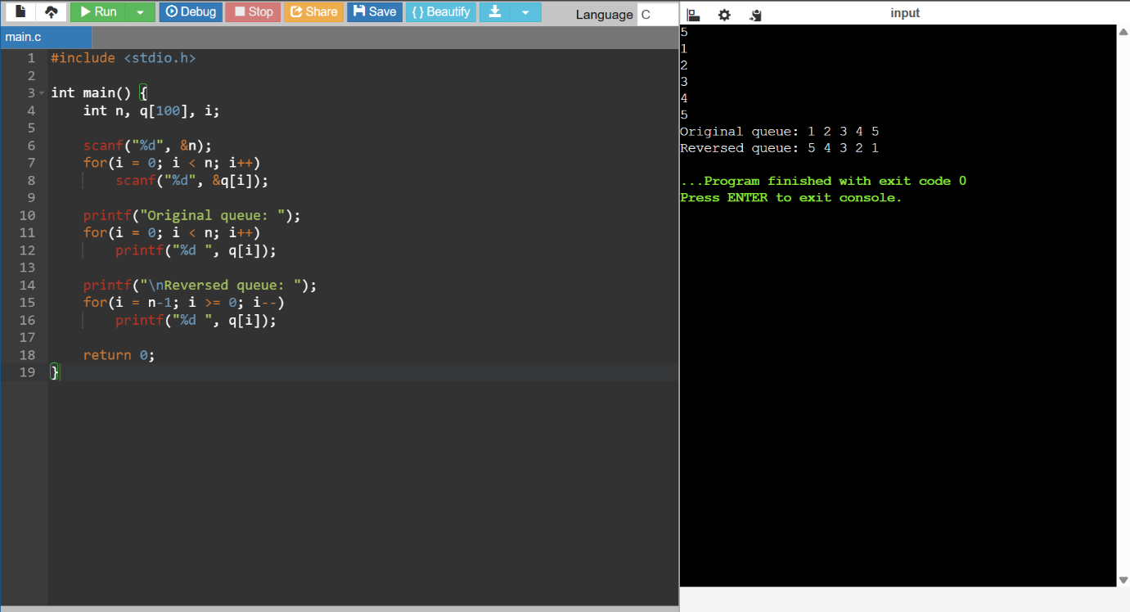
2. John is tasked with creating a program to manage student roll numbers using
a singly linked list.

Write a program for John that accepts students&#39; roll numbers, inserts them at the end
of the linked list, and displays the numbers.
Input Format
The first line of input consists of an integer N, representing the number of students.
The second line consists of N space-separated integers, representing the roll
numbers of students.
Output Format
The output prints the space-separated integers singly linked list, after inserting the
roll numbers of students at the end.
Refer to the sample output for formatting specifications.
Constraints
1 ≤ N ≤ 10
1 ≤ roll numbers ≤ 1000

Sample Input Sample Output
5 101 103 102 105 104
101 103 102 105 104
CODE:
#include <stdio.h>
#include <stdlib.h>
struct node {
int data;
struct node *next;
};
int main() {
int n, i, x;
struct node *head = NULL, *temp, *newnode;
scanf("%d", &n);
for(i = 0; i < n; i++) {
scanf("%d", &x);
newnode = (struct node*)malloc(sizeof(struct node));
newnode->data = x;
newnode->next = NULL;
if(head == NULL)
head = temp = newnode;
else {
temp->next = newnode;
temp = newnode;
}
}

temp = head;
while(temp) {
printf("%d ", temp->data);
temp = temp->next;
}

return 0;
}
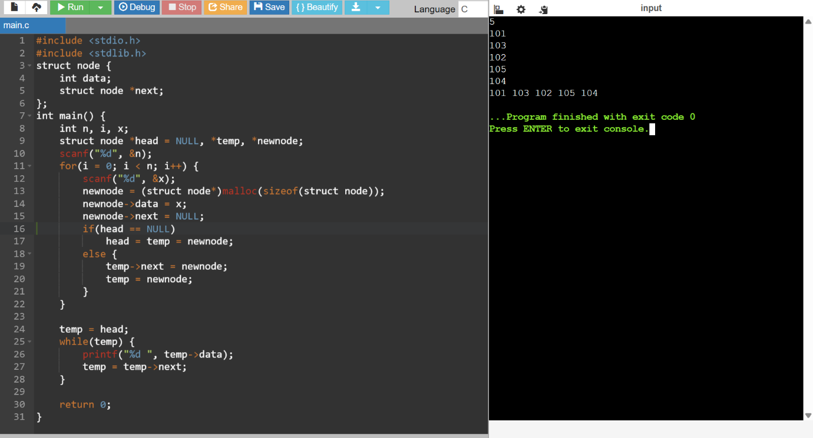
3. Arun is tasked with implementing a program to reverse a singly linked list. The
program should populate the list elements by inserting them at the beginning,
traverse the list and reverse the order of its elements.
Since Arun is new to programming, you have to guide him through the task.
Input Format

The first line of input consists of an integer N, representing the linked list size.
The second line consists of N space-separated list elements.
Output Format
The first line of output prints the list elements after inserting them at the
beginning.
The second line prints the reversed linked list.
Refer to the sample output for formatting specifications.
Constraints
1 ≤ N ≤ 25
1 ≤ list elements ≤ 1000
Sample Input Sample Output
5 31 62 47 85 23
23 85 47 62 31 23 85 47 62 31
CODE:
#include <stdio.h>
#include <stdlib.h>
struct node {
int data;
struct node *next;
};
int main() {
int n, x, i;
struct node *head = NULL, *newnode, *temp;
struct node *prev = NULL, *curr, *nextnode;
scanf("%d", &n);
for(i = 0; i < n; i++) {
scanf("%d", &x);
newnode = (struct node*)malloc(sizeof(struct node));
newnode->data = x;
newnode->next = head;
head = newnode;
}

temp = head;
while(temp) {
printf("%d ", temp->data);
temp = temp->next;
}
curr = head;
while(curr) {
nextnode = curr->next;
curr->next = prev;
prev = curr;
curr = nextnode;
}
head = prev;
printf("\n");
temp = head;
while(temp) {
printf("%d ", temp->data);
temp = temp->next;
}
return 0;
}
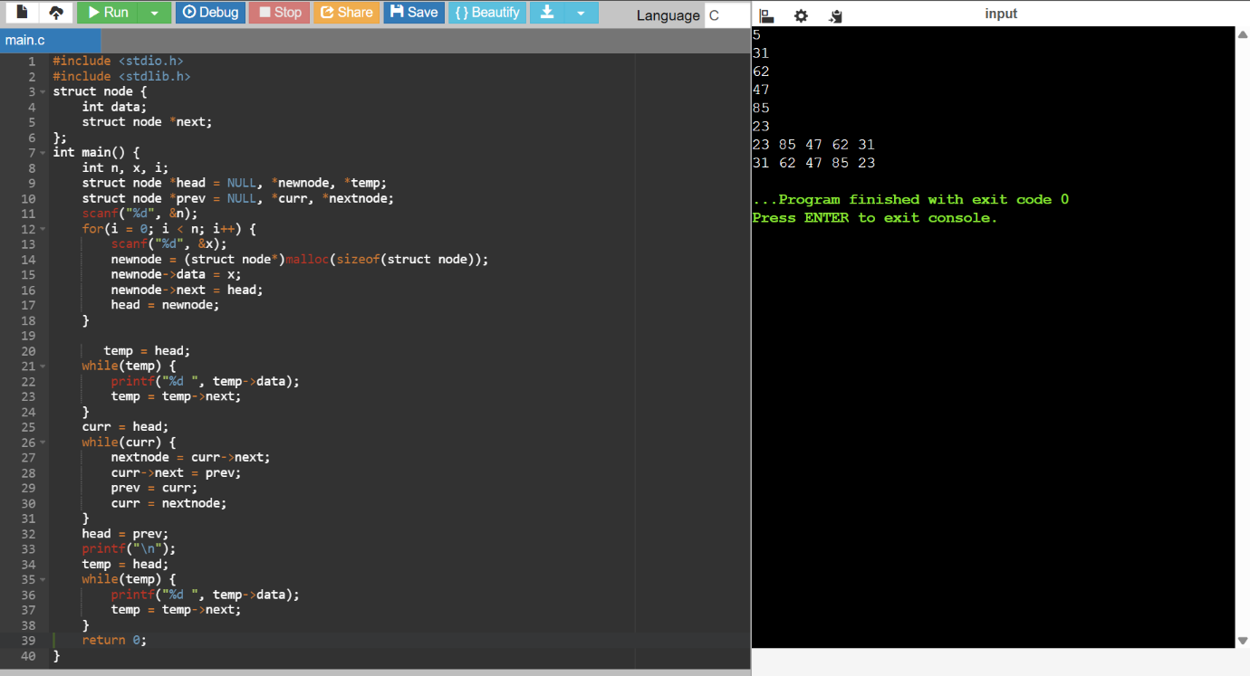
4. Dev is tasked with creating a program that efficiently finds the middle element
of a linked list. The program should take user input to populate the linked list
by inserting each element into the front of the list and then determining the
middle element.

Assist Dev, as he needs to ensure that the middle element is accurately identified
from the constructed singly linked list:
If it&#39;s an odd-length linked list, return the middle element.
If it&#39;s an even-length linked list, return the second middle element of the two
elements.
Input Format
The first line of input consists of an integer n, representing the number of elements in
the linked list.
The second line consists of n space-separated integers, representing the elements
of the list.
Output Format
The first line of output displays the linked list after inserting elements at the front.
The second line displays &quot;Middle Element: &quot; followed by the middle element of the
linked list.
Refer to the sample output for formatting specifications.
Constraints
1 ≤ n ≤ 30
1 ≤ elements ≤ 100
Sample Input Sample Output
5 50 40 30 20 10
10 20 30 40 50 Middle Element: 30
CODE:
#include <stdio.h>
#include <stdlib.h>

struct node {
int data;
struct node *next;
};
int main() {
int n, x, i;
struct node *head = NULL, *newnode, *temp;
struct node *slow, *fast;
scanf("%d", &n);
for(i = 0; i < n; i++) {
scanf("%d", &x);
newnode = (struct node*)malloc(sizeof(struct node));
newnode->data = x;
newnode->next = head;
head = newnode;
}
temp = head;
while(temp) {
printf("%d ", temp->data);
temp = temp->next;
}
slow = fast = head;
while(fast && fast->next) {
slow = slow->next;
fast = fast->next->next;
}
printf("\nMiddle Element: %d", slow->data);
return 0;
}
